WBSC FAST PITCH STRIKE ZONE

5.1.41 STRIKE ZONE

The space over any part of home plate between the bottom of the batter’s sternum (chest plate) and the bottom of the batter’s knee cap, when they assume their natural batting stance. (MP Only – The space over home plate between the batter’s armpits and the top of the knees when they assume their natural batting stance.) The natural batting stance is the stance the batter takes after the release of the pitch when deciding to swing or not swing at the pitch.

5.4.3

c) A strike is called the ball is live and runners may advance with liability to be
put out:
- when any part of a pitched ball enters the strike zone before touching
the ground and the batter does not swing, (FP Only - Provided the top of the ball is at
or below the sternum or the bottom of the ball is at or above the bottom of the knee cap);

1 BALL; 2 STRIKE; 3 BALL; 4 BALL; 5 STRIKE; 6 STRIKE 7 BALL;

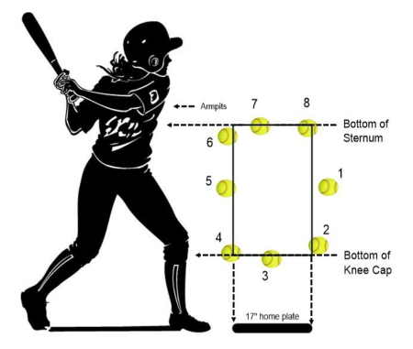

WBSC(快速壘球)好球帶
5.1.41. 好球帶
擊球員於正常打擊姿勢下，本壘板上方，介於擊球員胸骨底部及膝蓋底部之間
的立體空間為該擊球員的好球帶。(修正式專用: 擊球員於正常打擊姿勢下，
本壘板上方，介於擊球員腋部及膝蓋上方之間的立體空間為該擊球員的好球帶)
所謂正常打擊姿勢指的是：投手球投出後，擊球員決定揮棒或不揮棒那時刻的
姿勢。

5.4.3
(C) 下列狀況宣告為“好球”；活球，比賽繼續，跑壘員可負險進壘。
i. 當投出之球的任何部分，在球接觸地面之前有進入好球帶，且擊球員未揮棒。
(快速FP專用：如果球的頂部位於胸骨下方或球的底部位於膝蓋底部或上方)

WBSC SOFTBALL MALE AND FEMALE FAST PITCH PITCHING RULE
POINTS OF EMPHASIS

1) Upon the ball being returned to the pitcher (ball in the air on the way back to the pitcher or the
catcher in a position to return the ball), the pitcher has 20 seconds to start the pitch.
2) Prior to starting the pitcher, the pitcher, must place the pivot foot on the pitching plate, and with
the hands apart, take a signal or appear to take a signal from the catcher.
3) The pitcher must then maintain contact with the pitching plate with the pivot foot and must place the stepping in contact with the pitching plate or behind the pitching plate within the 61 Cm (24 in) of the pitching plate before bring the hands together for the pause.
4) Once the pause has begun, the pivot foot and stepping foot must remain stationary until the start of the pitch. The pause must be held for a minimum of 2 seconds and a maximum of 5 seconds. The pitcher may ask for time during the pause provided the hands remain together or the pitcher steps back off the pitching plate with the hands together.
5) The pitch starts when the pitcher separates the hands or begins any movement that is part of the
pitching motion. The pitchers feet may only move forward once the pitch starts.
6) The pitcher may take one step with the leading, non-pivot foot simultaneously with the release of the ball. The step must be forward toward the batter and within the 61.0 cm (24 in) length of the pitcher’s plate. It is not a step if the pitcher slides either foot across the pitcher’s plate, provided contact is maintained with the plate, and there is no movement backward off the plate.
7) The pivot foot must remain in contact with the pitcher’s plate, or push off and drag away from the pitcher’s plate or be airborne prior to the stepping (non-pivot) foot touching the ground. The pitcher may leap from the pitchers plate, land and with a continuous motion deliver the ball to the batter. The pivot foot may follow through with the pitcher’s continuous action.

WBSC男子及女子快速壘球—投球規定
重點強調
- 當球被送回投手（球傳回投手在空中飛行中或捕手已就回傳位置），投手有20秒開始投球。
- 投手開始投手前，必須將軸足置於投球板上，雙手分開，與捕手溝通暗號或假裝
與捕手溝通暗號。
- 投手在雙手合在一起靜止動作之前，軸足必須保持與投手板接觸，而跨足可接觸投手板，也可置於投手板後方，但必須位於投手板寬度61公分（24英寸）內。
- 一旦靜止動作開始，軸足和跨足必須保持靜止直到開始投球。靜止動作必須維持至少2秒，最長5秒。此靜止期間投手可以要求暫停，只要雙手保持合在一起，或者雙手合在一起向後退出投手板。
- 投手雙手分開或者身體開始任何投球的擺動，則視為開始投球；投手開始投球，
雙腳都只能向前移動。
- 投手跨足可向前跨一步，隨即將球投出；跨足必須是向前、在投手板寬度61.0公分（24英寸）內、向著擊球員跨出，投手的任何腳在投手板上移動，只要仍與投手板保持接觸，而且沒有向後離開投手板取得動能，都不視為跨步。
- 在跨足接觸地面之前，投手的軸足必須仍與投手板接觸，或者從投手板蹬離然後拖地而出，或者騰空躍出；投手可從投手板騰空躍出，落地、然後將球投出，但
動作必須連貫、一氣呵成；在連續動作中軸足可尾隨在跨足之後。

